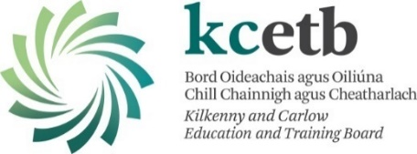
Assessment Malpractice Appeals Result Notification Letter

Centre:
Learner Name:
Reference Identifier:

Dear Mr/Ms < Name>,
Cc Centre Manager

KCETB has processed your appeal documentation in line with standard KCETB policies and procedures. Please find below the outcome of your appeal:

Successful | A review of the assessment malpractice allegation evidence has been conducted and concluded that the assessment malpractice allegation should be overturned.  You will be contacted by your centre manager (or nominee) in relation to this.

Unsuccessful: | A review of the assessment malpractice allegation evidence has been conducted and concluded that the assessment malpractice allegation should be upheld.

If you require any further information, please do not hesitate to contact me.

Yours sincerely

____________________ Date: _______________
Quality Assurance
056 781 3098 qa.info@kilkennycarlowetb.ie

For office use only:
Action | QA Office | Centre Manager
Copy of letter sent to Centre Manager | Yes ☐ No ☐
Letter sent to learner |  | Yes ☐ No ☐
Signed:
Date:

